New plastic guide trough keeps energy chains safely and easily on track
The guidelite plus enables users to make savings on purchase and installation

The motion plastics specialist igus has launched a new modular guide trough system, which is entirely made of tribo-optimised plastic: guidelite plus. The system is very light, easy to install, cost effective and is also suitable for use in harsh environments.

Guide troughs, usually made from aluminium or steel, ensure correct operation and a long service life for energy chains in gliding applications with long travels. The new guidelite plus from igus is a guide trough that is made entirely of plastic and is easy to assemble. Individual elements made of abrasion-resistant high-performance plastic can be connected together very quickly and without tools by hand due to a locking mechanism specially designed for this system. The low weight of the plastic parts helps with installation, but is also advantageous where lightweight solutions are needed. A special expansion joint, which is provided in every second link of the trough elements, guarantees flexibility and adaptability especially in case of large temperature variations. Thus, the product can also be used without restrictions in outdoor applications.

Plastic for harsh application areas
The plastic guidelite plus guide trough is also suitable for applications where metallic alternatives are very expensive or cannot be used due to aggressive chemicals or risk of corrosion. For these applications, the guidelite plus can be manufactured from a special plastic that is more resistant to chemicals. Thereby new applications are possible in the galvanising sector or fertilizer production, where expensive stainless steel solutions were previously required. But even in other dynamic uses, in which long travels have to operate reliably without failure or maintenance at a low speed of up to 1 m/s, the guidelite plus is an alternative that saves time and cost. In purchasing alone, double digit percentage savings are possible compared to aluminium or stainless steel troughs.

The plastic guide trough is available for energy chains with outer heights of 35, 50 and 64 millimetres. The use of guidelite plus is economical in both new installations and retrofitting of existing plants. Much cheaper than a comparable stainless steel or aluminium trough, the user saves twice, in the purchase as well as the fast assembly.

This video illustrates the structure and nature of the guidelite plus from igus: https://youtu.be/P_JCObtDTxc

PRESS CONTACT:  Oliver Cyrus  Head of Media and Advertising  igus® GmbH  Spicher Strasse 1a  51147 Cologne  Tel. 0 22 03 / 96 49-459  Fax +49 22 03 / 96 49-631  ocyrus@igus.de  www.igus.de/de/presse | ABOUT IGUS:  igus GmbH is a globally leading manufacturer of energy chain systems and polymer plain bearings. The Cologne-based family business has offices in 36 countries and employs around 2,700 people around the world. In 2014, igus generated a turnover of 469 million euros with motion plastics, plastic components for moving applications. igus operates the largest test laboratories and factories in its sector to offer customers quick turnaround times on innovative products and solutions tailored to their needs.

The terms ‘igus, e-ketten, e-kettensysteme, chainflex, readycable, easychain, e-chain, e-chainsystems, energy chain, energy chain system, flizz, readychain, robolink, pikchain, triflex, twisterchain, invis, drylin, iglidur, igubal, xiros, xirodur, plastics for longer life, CFRIP, dryspin, manus and vector’ are protected by trademark laws in the Federal Republic of Germany and internationally, where applicable.

Captions:

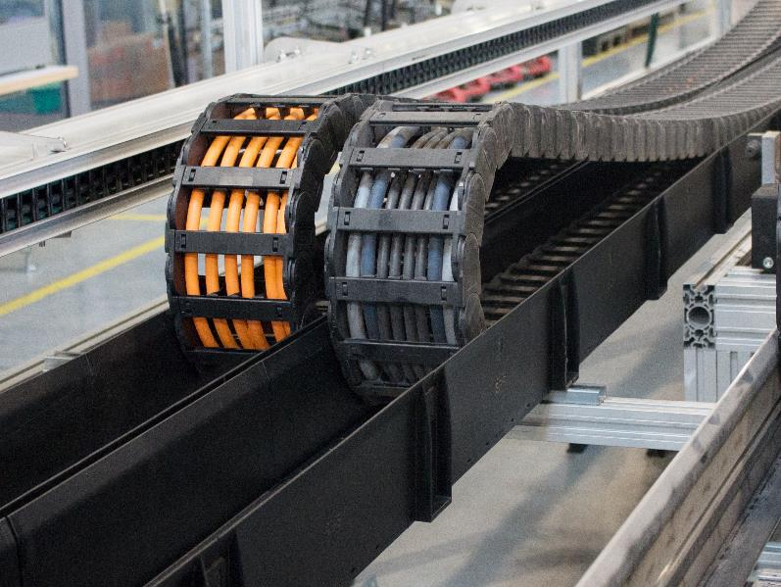
Picture PM2915-1
The energy chain guide trough guidelite plus from igus guarantees a low-friction, protected operation of the energy chain at a low price and weight. The picture shows a test set-up in the 1,750 square-metre test lab at igus. (Source: igus GmbH).

